APPENDIX 1
Graphical results of net-squared displacement from location of capture of murrelets fit with a PTT, central Oregon coast, May 2016. Two figures are presented for each individual, the first showing the median predicted net-squared displacement calculated from 10 000 tracks, simulated from the correlated random-walk model; and the second showing the median and 95% confidence intervals calculated from 10 000 tracks, simulated from the correlated random-walk model. Results for individuals 160352 and 160353 are not included because too few satellite fixes were recorded.
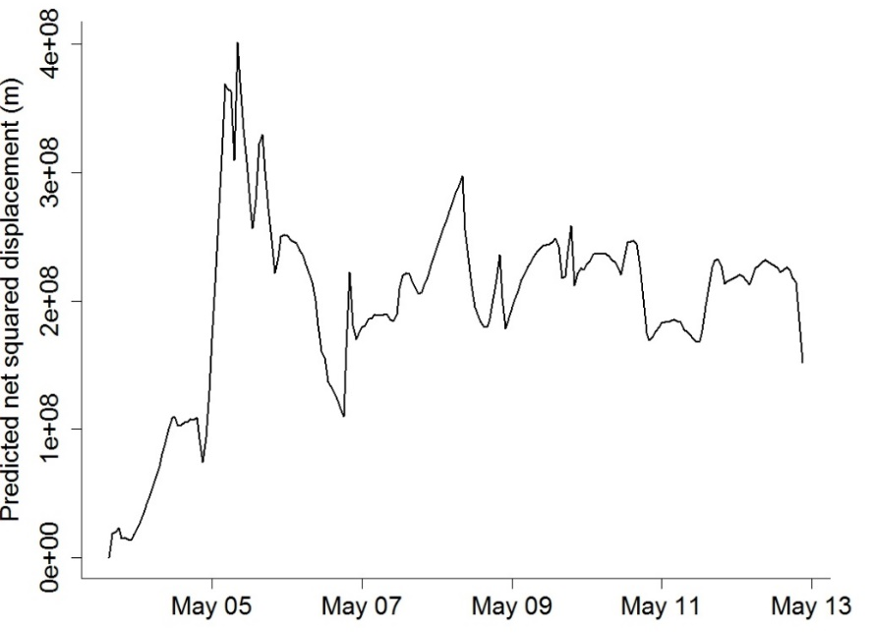
A1.1. Net-squared displacement from the capture location by date for Marbled Murrelet 160348.
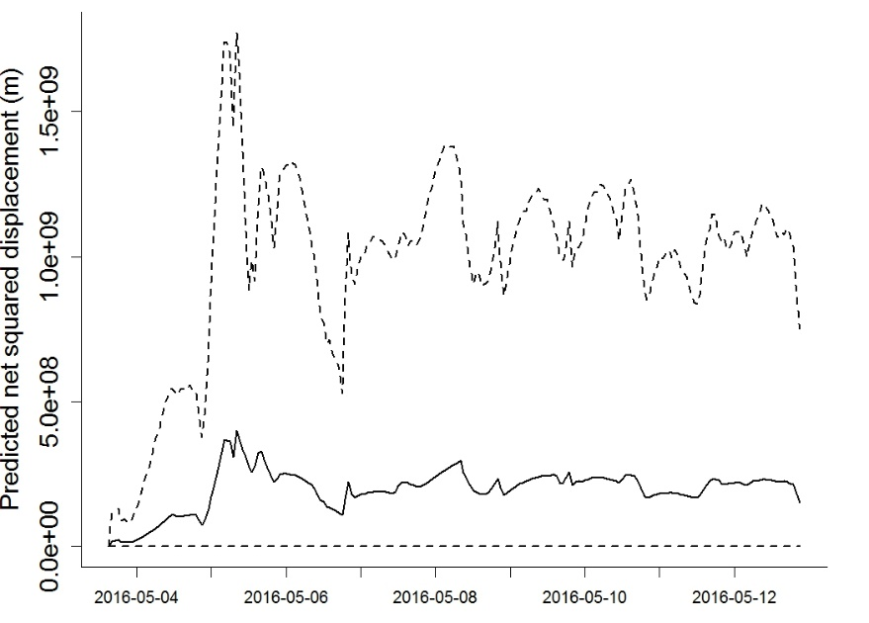
A1.2. Mean (solid line) and 95% confidence intervals (dashed lines) of net-squared displacement from the capture location by date for Marbled Murrelet 160348.

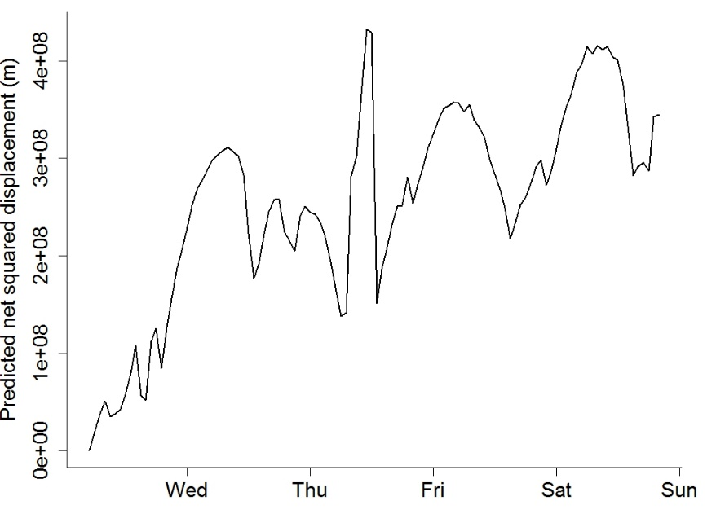
A1.3. Net squared displacement from the capture location by date for Marbled Murrelet 160349.
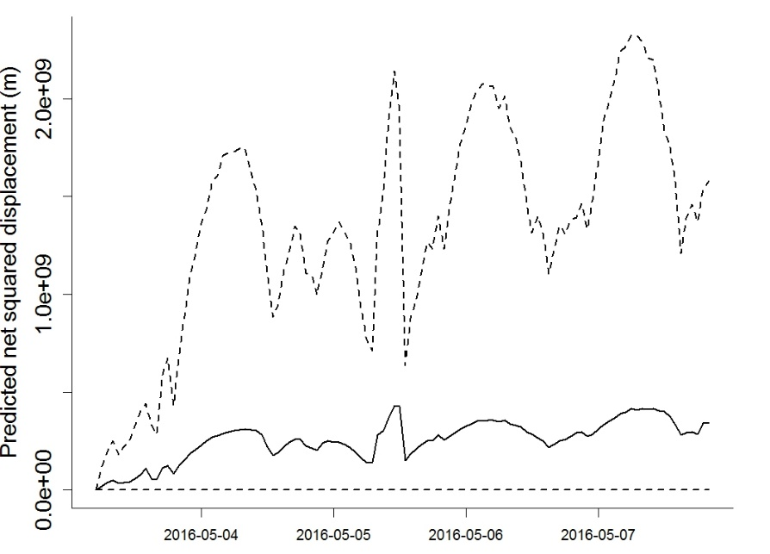
A1.4. Mean (solid line) and 95% confidence intervals (dashed lines) of net-squared displacement from the capture location by date for Marbled Murrelet 160349.

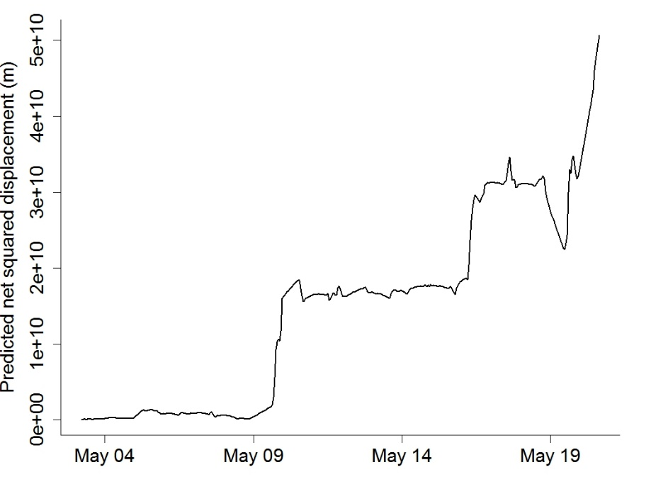
A1.5. Net squared displacement from the capture location by date for Marbled Murrelet 160350.
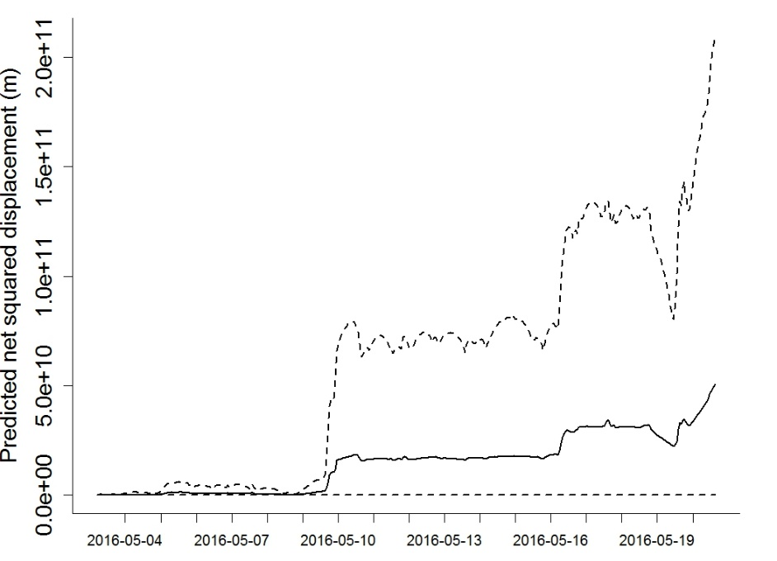
A1.6. Mean (solid line) and 95% confidence intervals (dashed lines) of net-squared displacement from the capture location by date for Marbled Murrelet 160350.
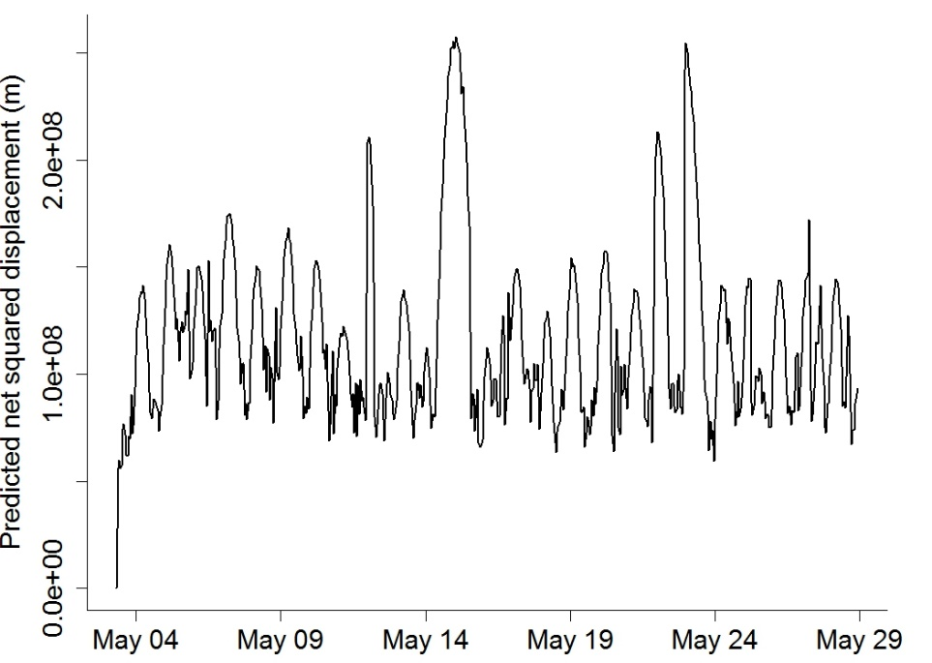
A1.7. Net-squared displacement from the capture location by date for Marbled Murrelet 160351.
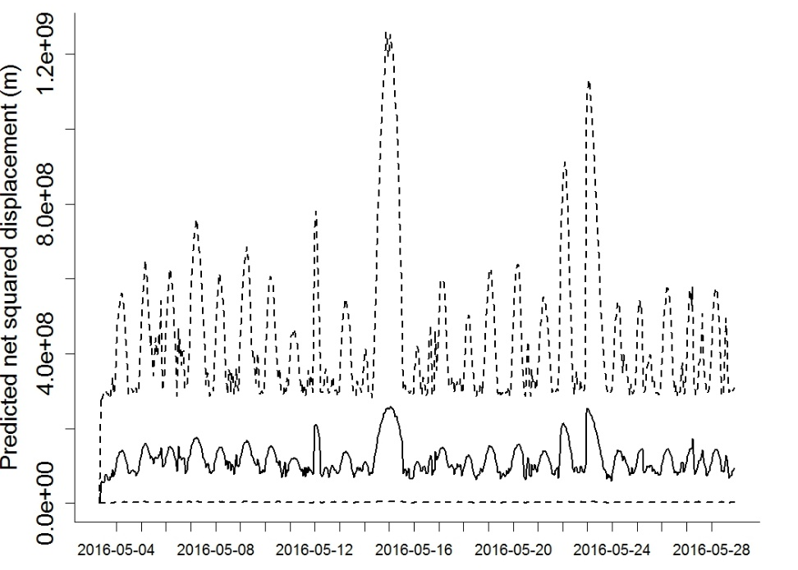
A1.8. Mean (solid line) and 95% confidence intervals (dashed lines) of net-squared displacement from the capture location by date for Marbled Murrelet 160351.

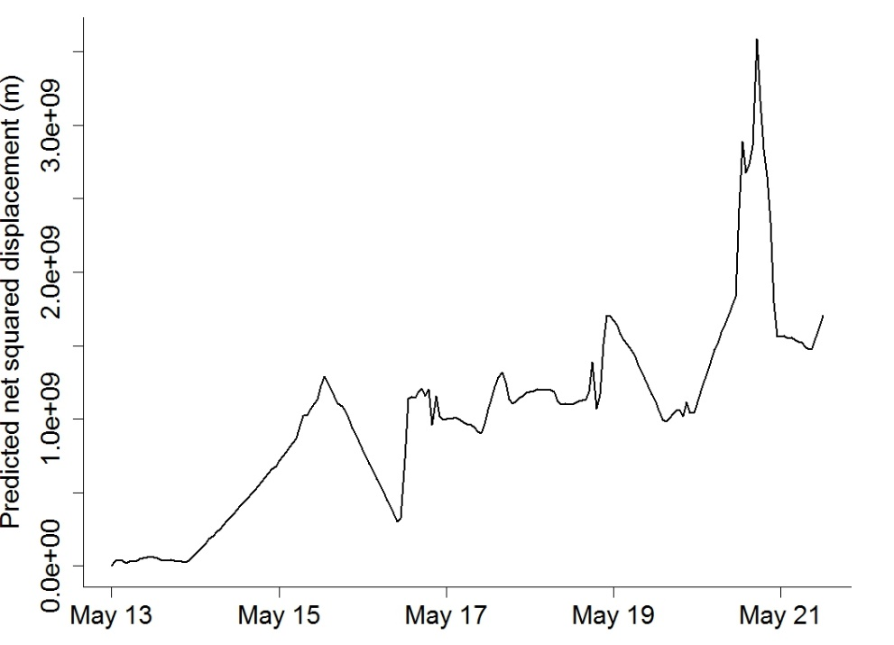
A1.9. Net-squared displacement from the capture location by date for Marbled Murrelet 160354.
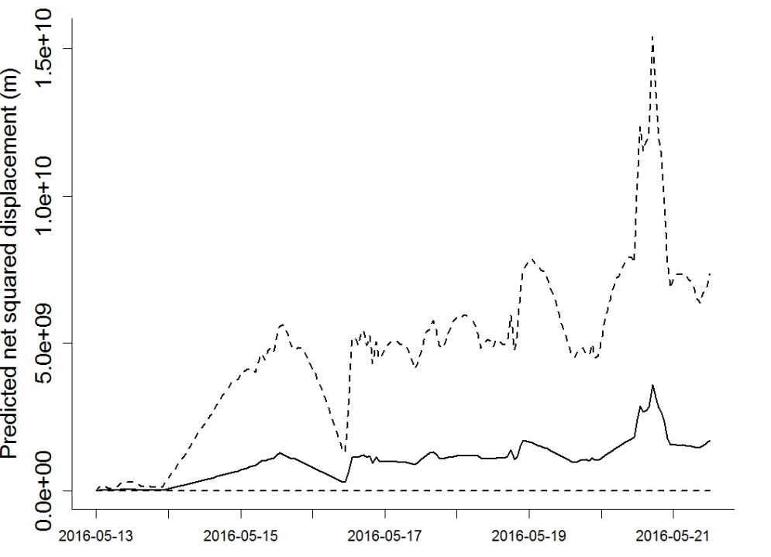
A1.10. Mean (solid line) and 95% confidence intervals (dashed lines) of net-squared displacement from the capture location by date for Marbled Murrelet 160354.

