APPENDIX 2
Graphical results of speed analysis (mean, m/h) for murrelets captured off the central Oregon coast and fit with a PTT, May 2016
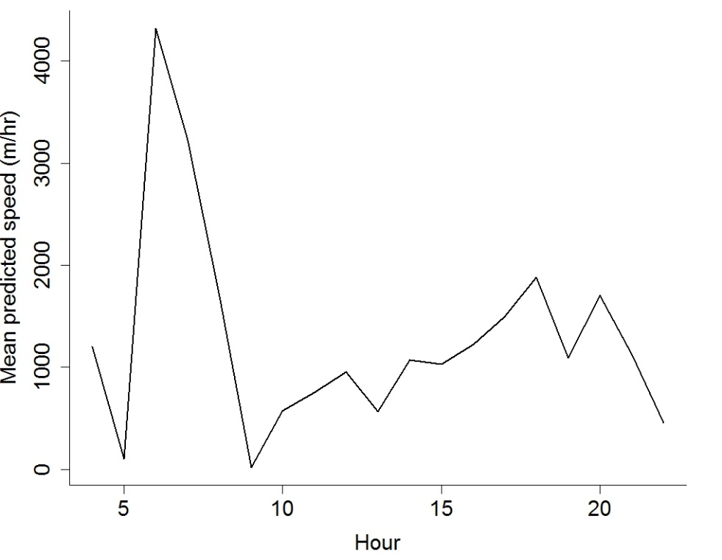
Marbled Murrelet 160348

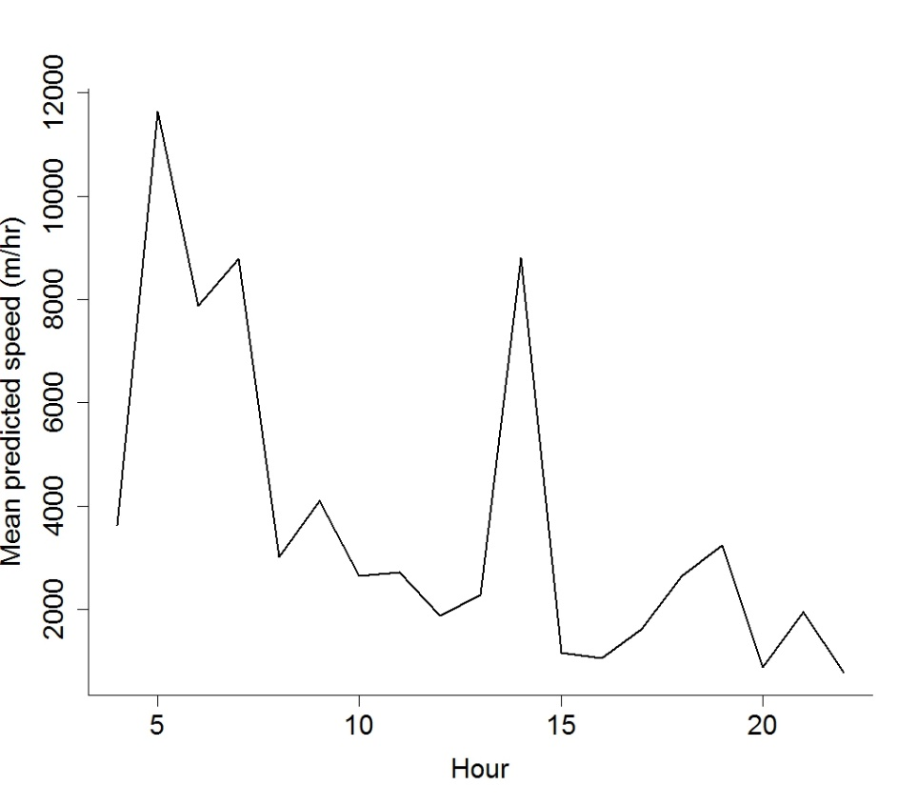
Marbled Murrelet 160349
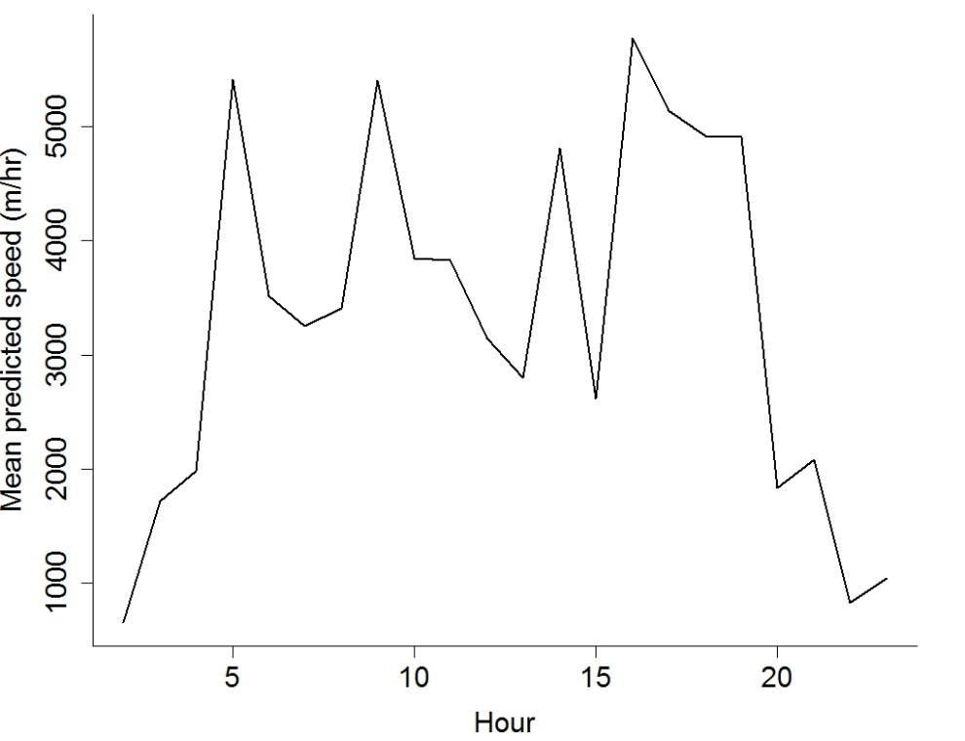
Marbled Murrelet 160350
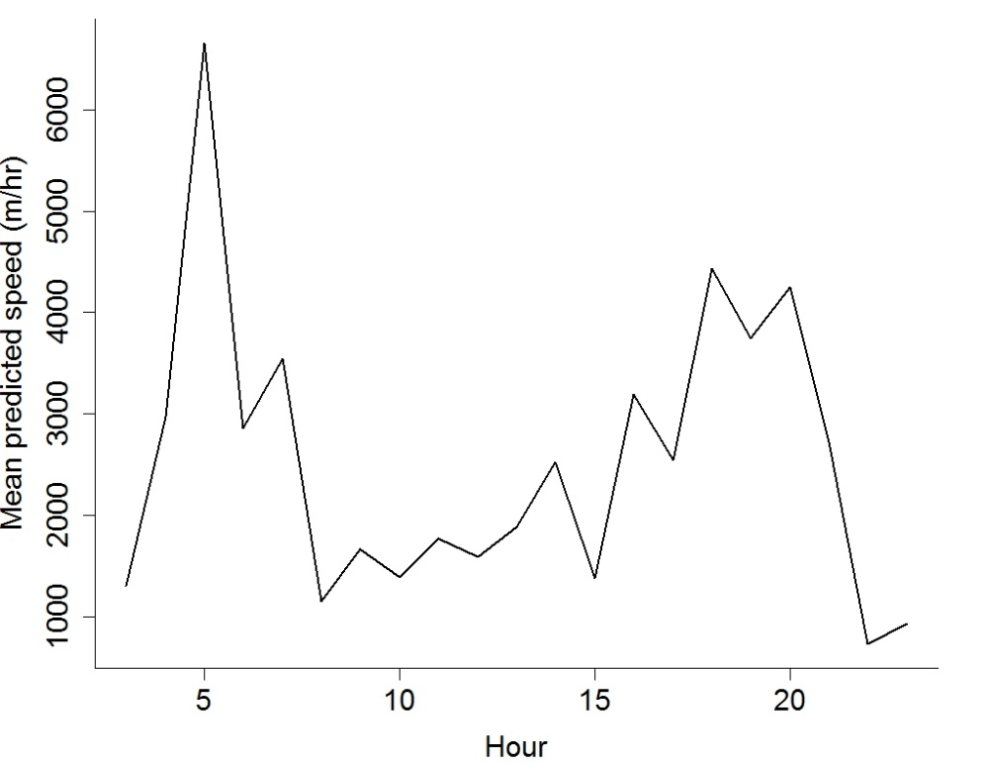
Marbled Murrelet 160351

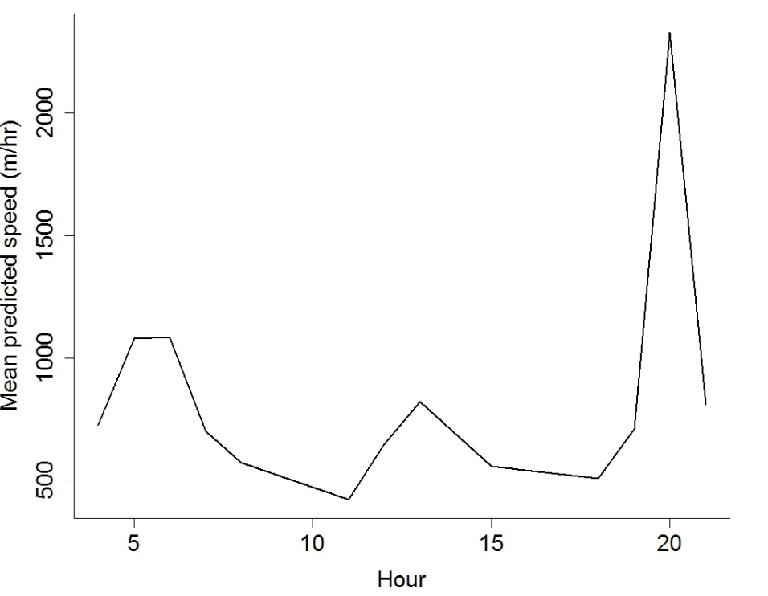
Marbled Murrelet 160352
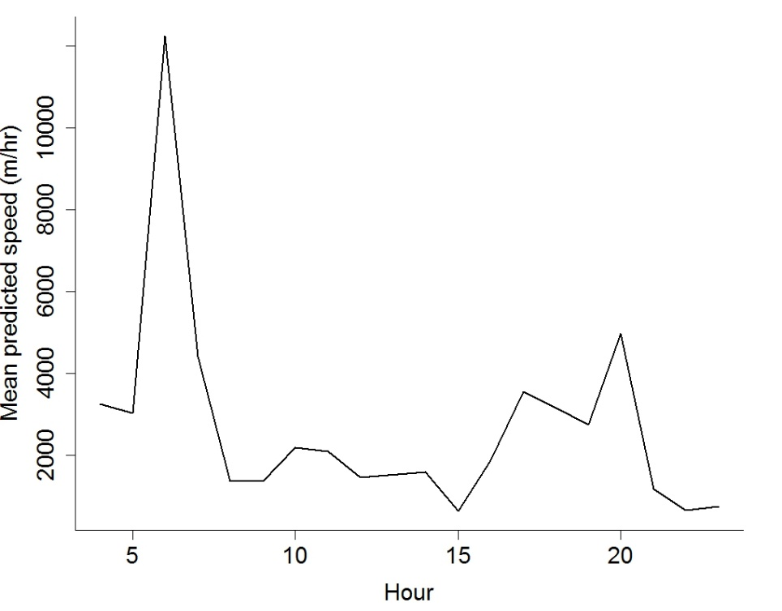
Marbled Murrelet 160354

