Appendix 1

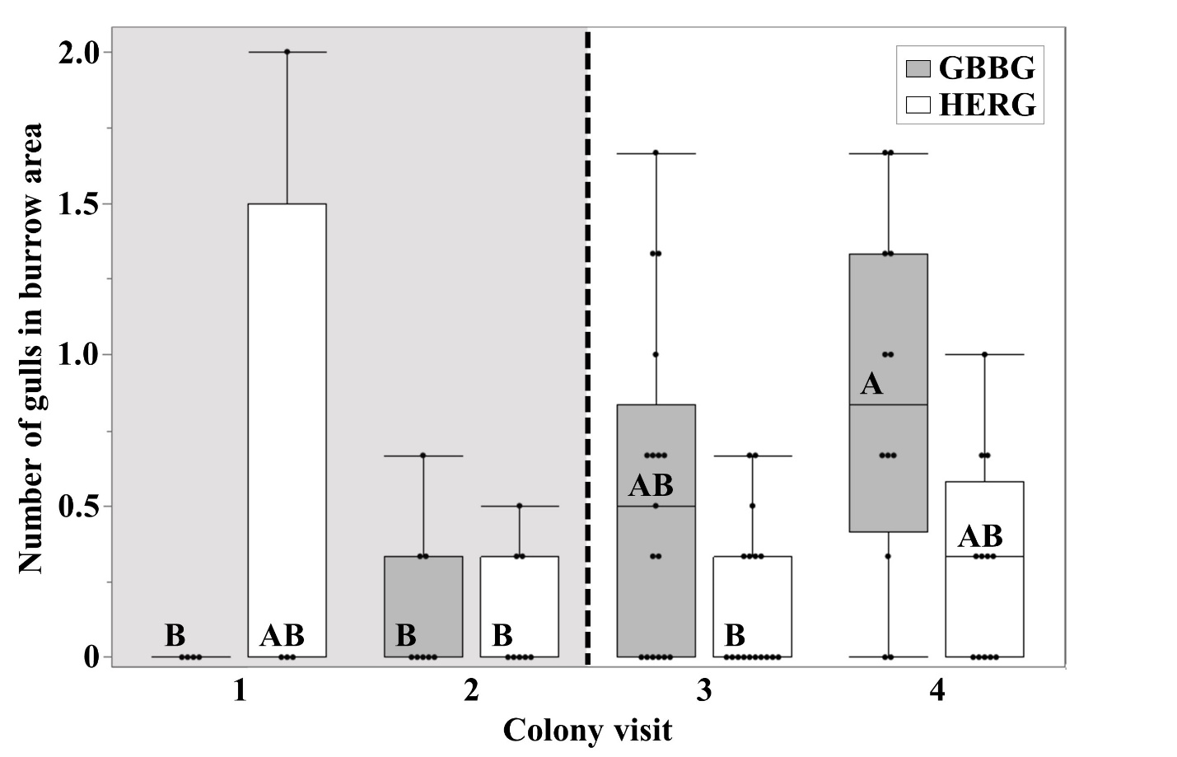
Figure A1. Mean number of Great Black-backed Gulls Larus marinus (GBBG) and American Herring Gulls L. argentatus smithsonianus (HERG) observed within a puffin burrow area during scan samples in each 30-min observation stint by colony visits: one (09–12 July 2022), two (15–19 July 2022), three (22–27 July 2022), and four (01–06 August 2022). The Capelin Mallotus villosus spawning period is indicated by the shaded background; the onset of puffin chick-rearing is indicated by the dashed vertical line. The mean number of gulls recorded in the puffin burrow area differed between species (F_{1,72} = 7.572, P = 0.007) and colony visits (F_{3,72} = 8.202, P = 0.005), with a significant interaction between the two (F_{3,72} = 9.921, P = 0.002). The results of a Tukey’s HSD post-hoc test are indicated, where factor levels not connected by the same letter differed significantly. Boxes show the median (center line), first and third quartiles (top and bottom, respectively), and minimum and maximum values (whiskers).

